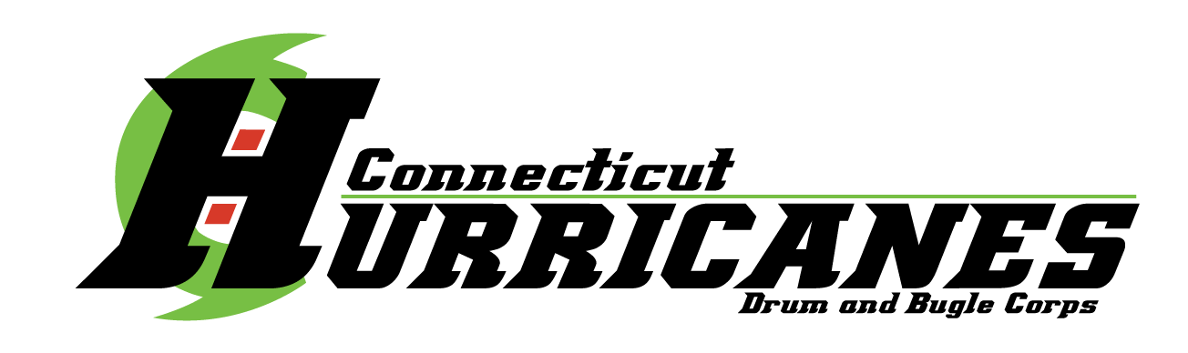
The Connecticut Hurricanes 2019 production is titled The Deadly 7. This show will bring the audience through an emotional journey, showcasing the themes of the seven deadly sins: Pride, Sloth, Gluttony, Greed, Lust, Envy and wrath. Get ready to experience the mood and emotions of The Deadly 7.
The Hurricanes are led onto the field by drum majors Jordan Marchand, Greg Ford and Sarah Smith.
Enjoy the show!
Corps Administration:  Director: Greg Sember  Assistant Director: David Pyrch  Operations Manager: Daniel Staffieri  Membership Manager: Jess Lyons  Volunteer Coordinator: Cathy Rehaag | Design & Instructional Staff:  Program Coordinator/Visual Design: Kevin Bell  Brass Arranger: Key Poulan  Brass Caption Head: Manny Arboleda  Brass Technicians: Brendan Michalko, Ted Adams, Matt Piros, Eric Stramel  Percussion Caption Head/Battery Arranger: Tony Gamble  Front Ensemble Arranger: Mike Wyatt  Sound Designer: Robert Bowen  Percussion Technicians: Ricky Cherry, AJ Rittenhouse, Anthony Davis  Front Ensemble Technicians: Collin Mason, Lernard Brand  Visual Caption Head: Ricky Grasso  Visual Technicians: Henry Flores, Tony Madore, Blair Roberts, Andi Conrad  Color Guard Caption Head: Brittany Gordon  Color Guard Technicians: John Duffy, Lauren Sember, Laura Choquette

